Fedex Oracle DBS with Dataguard with ORM stack

Introduction

The Data Guard implementation requires two databases: one in a primary role and one in a standby role. The two databases, primary database and standby database, together make a Data Guard association. Most of your applications access the primary database, while the standby database is a transactionally consistent copy of the primary database.

Workflow diagram to deploy the stack

Below diagram shows how the Terraform Artifact are applied in the OCI. While creating a ORM stack, using terraform deliverables Init, Plan and Apply is the flow to provision the resource in the OCI. We can have the deliverables in any of below.

- Git Lab/GitHub Repo
- Bit bucket
- Can be in folder/.zip in the local disk
- Object Storage Bucket
- Can be in compartment
- Oracle provided Template


Prerequisites:

- Collect the subnet_ocid from OCI console
- Refer env_var.sh file to set the variables
- Allow port number 1521 on both the subnets to enable the dataguard

Contents:

- Setup the Security Rules to enable Dataguard
- Provision DBS with Dataguard using OCI ORM Stack

Note: To enable Dataguard, setup the below security rules on both subnets primary and secondary subnet’s security lists
Step 1: To enable the DATAGUARD, Port 1521 should be opened on both the subnets. Create two subnets in VCN and add the following security rules to allow port 1521 as shown an example below
- Navigate to the OCI console and select VCN > subnet > security rules and add the following rules
Security List for Subnet on the Primary DB System:

Ingress Rules:

Stateless: No
Source: 10.0.1.0/24 (Secondary subnet's CIDR block)
IP Protocol: TCP
Source Port Range: All
Destination Port Range: 1521
Allows: TCP traffic for ports: 1521

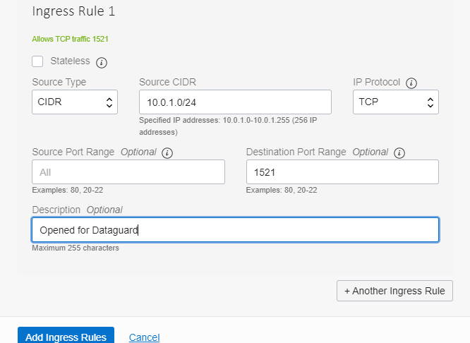

Egress Rules:

Stateless: No
Destination: 10.0.1.0/24 (Secondary subnet's CIDR block)
IP Protocol: TCP
Source Port Range: All
Destination Port Range: 1521
Allows: TCP traffic for ports: 1521

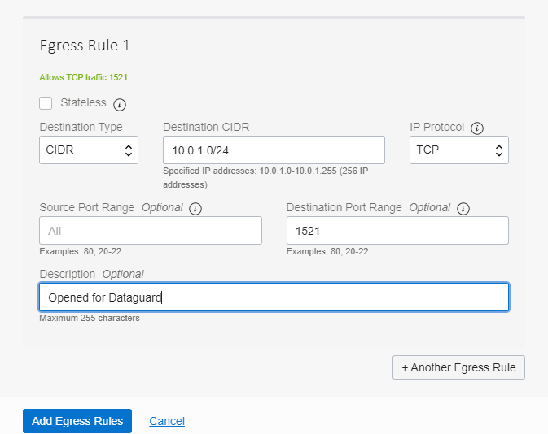

- Security List for Subnet on the Standby DB System

Ingress Rules:

Stateless: No
Source: 10.0.0.0/24 (Primary subnet's CIDR block)
IP Protocol: TCP
Source Port Range: All
Destination Port Range: 1521
Allows: TCP traffic for ports: 1521
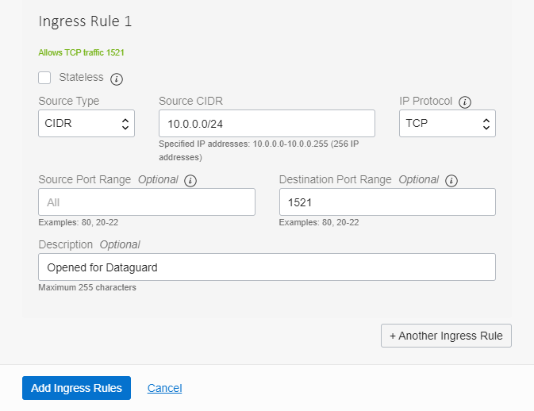

Egress Rules:

Stateless: No
Destination: 10.0.0.0/24 (Primary subnet's CIDR block)
IP Protocol: TCP
Source Port Range: All
Destination Port Range: 1521
Allows: TCP traffic for ports: 1521

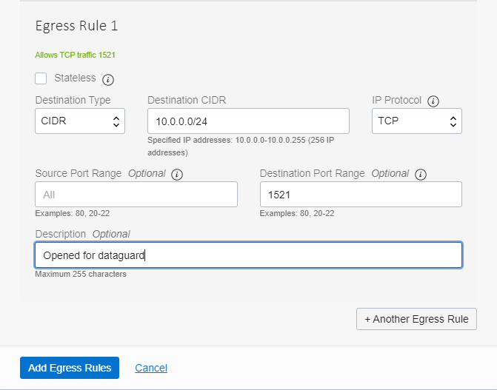

Create DBS with Dataguard through Oracle Resource Manager

Prerequisites:

- Allow Port number 1521 on both subnet to enable DBS Dataguard
- Collect Subnet OCID

Specifications:

Step 1: Login to the OCI console and navigate to
OCI Console >> Developer Services >> Stacks

Step 2: Click on create stack

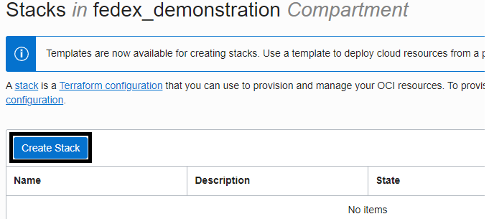

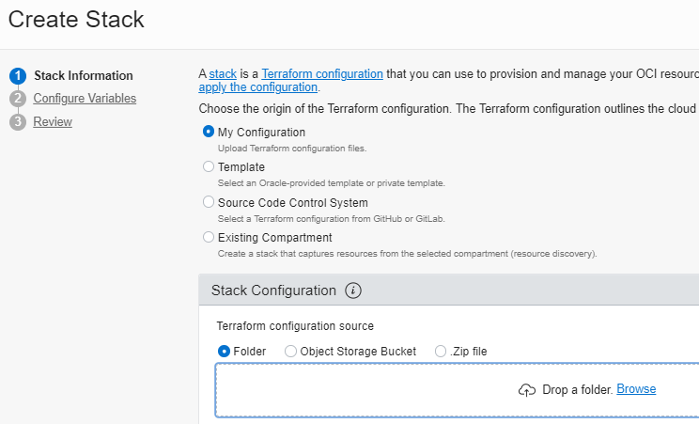

Step 3: In Stack Configuration upload the DBS_DATAGUARD.zip file that contains the terraform files

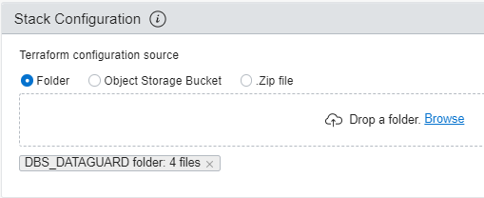

Step 4: Leave default for Working Directory, provide optional name, choose the compartment.

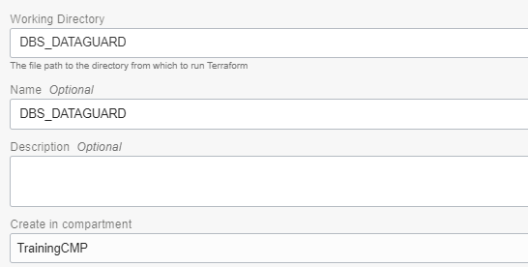

Step 5: Click Next, and provide all required variables, refer the env_var.sh file to set the environment variables

- Tenancy_ocid: <tenancy_ocid>
- Compartment_ocid: <compartment_ocid>
- Region: <region>
- Ssh_public_key: <ssh_public_key_for_dbs_system>
- Primary_dbs_display_name: <primary_dbs_display_name>
- Primary_dbs_hostname: <primary_dbs_hostname>
- Secondary_dbs_display_name: <secondary_dbs_display_name>
- Secondary_dbs_hostname <secondary_dbs_hostname>
- Dbs_db_name: <database_name>
- Admin_password: <database_admin_password>
- Primary_dbs_subnet_ocid: <primary_dbs_subnet_ocid>
- Secondary_dbs_subnet_ocid: <secondary_dbs_subnet_ocid>
- Is_dataguard_enabled: <true or false>
- Dbs_node_count: <node_count>
- Db_version: <db_version>
- Db_workload: <db_workload>
- Database_edition: <>
- Data_storage_size_in_gb: <storage_size_in_gb>
- Database_instance_shape: <Database_instance_shape>
- License_model: <license_model>
- Auto_backup_enabled: <true or false>
- Project_tag: <project_tags>

For Example:

tenancy_ocid="ocid1.tenancy.oc1..aaaaaaaawmznmfxh22f2zbh23lgl"
region="us-ashburn-1"
compartment_ocid="ocid1.compartment.oc1..aaaaaaaa64n5x7te7xv"
primary_dbs_subnet_ocid="ocid1.subnet.oc1.iad.aaaaaajtaf3zcm"
secondary_dbs_subnet_ocid="ocid1.subnet.oc1.iad.aaaacqq6qt"
ssh_public_key="ssh-rsa 3NzaC1yc2EAAAADAQABAAABAQCy8gQsA+pwib"
database_instance_shape="VM.Standard2.4"
admin_password="WelcomE##123"
dbs_db_name="fedexdb"
primary_dbs_display_name="fedex_dbs"
primary_dbs_hostname="fedexdbnode"
secondary_dbs_display_name="fedex_dbs"
secondary_dbs_hostname="fedexdbnode"
dbs_node_count="1"
db_version="19.11.0.0"
db_workload="OLTP"
database_edition="ENTERPRISE_EDITION_EXTREME_PERFORMANCE"
data_storage_size_in_gb="1024"
license_model="LICENSE_INCLUDED"
is_dataguard_enabled="false"
auto_backup_enabled="false"
project_tag={"fedexgovernance.Environment" = "L1 (Unit Test)", "fedexgovernance.eai" = "3537143", "fedexgovernance.opco" = "FXL", "fedexgovernance.sub_opco" = "FSC (FedEx Supply Chain)", "fedexgovernance.itowner" = "2750149 (Curtis Hofmann)", "fedexgovernance.creator" = "2776212 (Jeffrey Hafner)", "FSCCustomer.MULTI" = "TRUE", "fedexgovernance.costcenter" = "10137.725800.1000263.107289"}

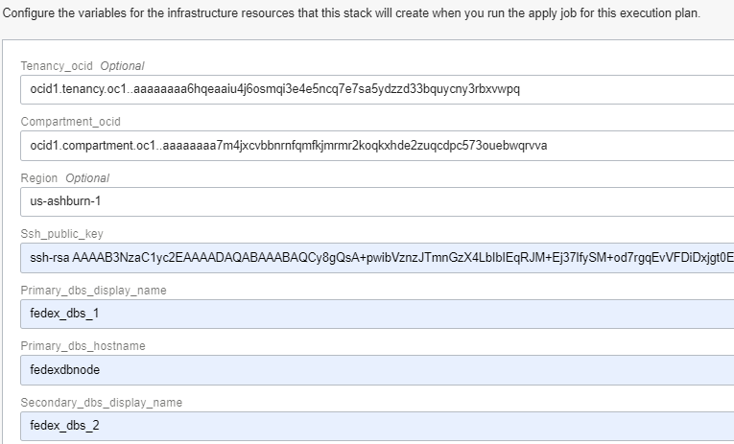

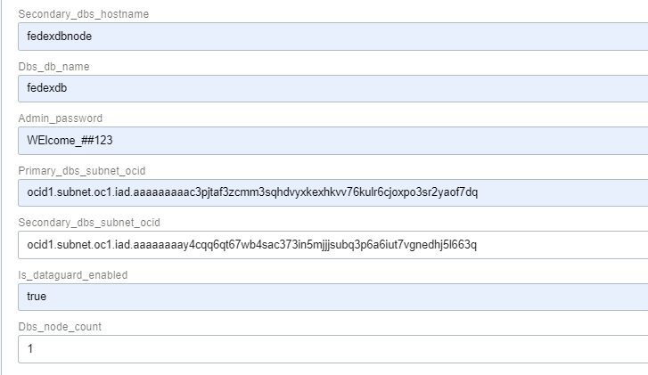
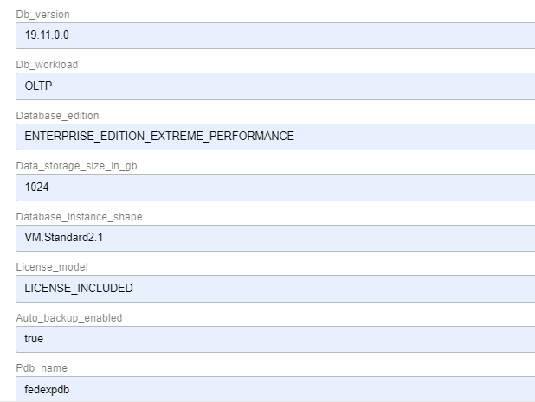
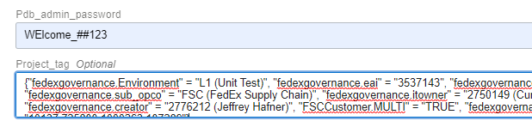
Step 6: Click on Review and create

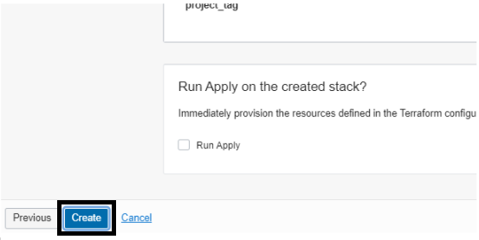

Step 7: Click on Plan and review

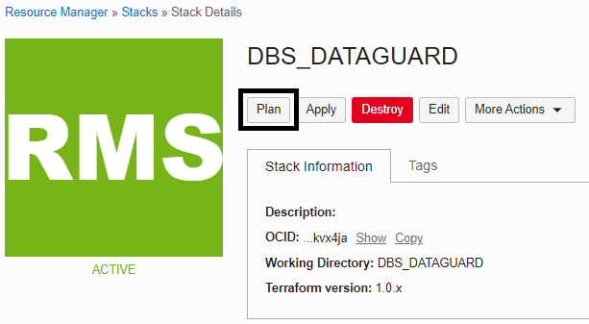

Step 8: Click on Apply to create DBS

